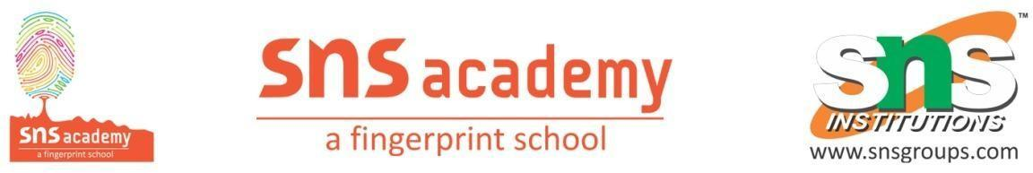
Periodic Test III – 2022-2023
Name: ______________________  Grade: I ______  Subject: EVS  Date: 9-11-22  Time: 45 mins | Marks obtained:
 | Total:20

I. Fill in the blanks using help box (5 X1=5)
energy live three meat morning

1. We eat ______________ meals in a day.
2. We need food to ______________ or grow.
3. Healthy food gives us ___________ to work and play.
4. Breakfast is the _____________ meal.
5. We get ________________ from animals.

II. Name the given water body. ( 3 X1=3)
6.
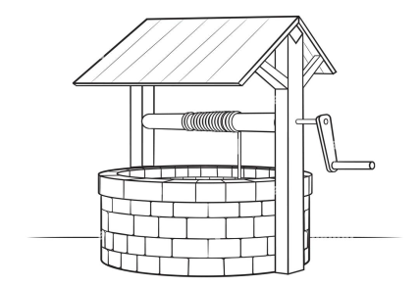 _______________________
7.
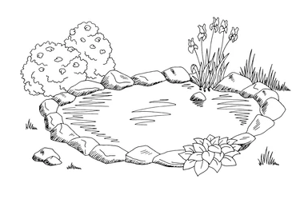 __________________

8.
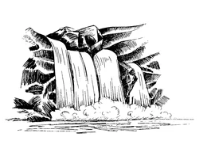 ________________________

III. Match the following (5X1=5)
9. Lunch | Salt water
10. Milk | Junk food
11. River and stream | Afternoon
12. French fries | Healthy bone
13. Ocean | Fresh water

IV. Write true or false. (4 X1=4)
14. We should waste water. _______________
15. Banana is a vegetable. ________________
16. A leaking tap should be fixed immediately. __________
17. We eat food when we feel hungry. _______________

V. Choose the best answer. (3X1=3)
18. We should wash our _______________ before eating .
a. hands b. hair c. stomach d. toes

19. We get fruits and vegetables from _______________
a. water b. plants c. egg d. meat

20. We need water to ___________________
a. drink b. laugh c. sleep d. breathe

